Program 2

Pong Lee

Part 1

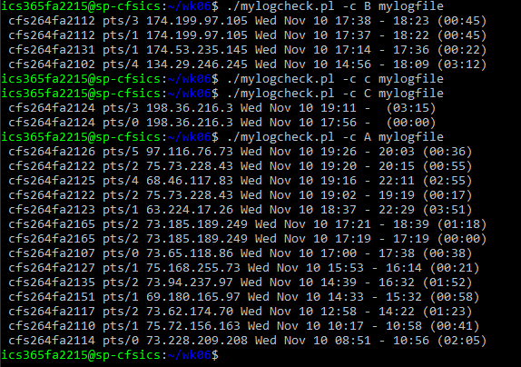

Part 2(below)

